Basma El Shenawy

900150283

Assignment 2 documentation

OOP-Spring 2017

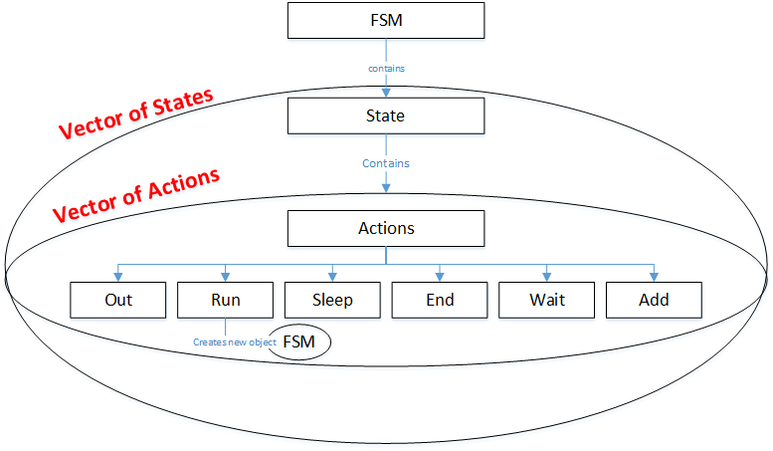**Diagram**

**Documentation**

**Class FSM**

Constructor: parameter is a string which is a path to the FSM's text file. It opens the text file and take the FSM's data and fill the data structure in the private part.

Move/copy constructors: parameter is FSM create a new FSM and initialize it using the parameter.

Destructor: De-allocates the memory.

Exec: calls function exec for each state.

**Class State**

Constructor: creates a new state and assigns it a name.

Destructor: de-allocates memory.

Move/copy constructors: parameter is State create a new State and initialize it using the parameter.

Getactions: receives a string and translates it into actions and pushes them in a vector of actions.

Exec: calls function perform for the actions in the vector of actions.

**Class Actions**

Abstract class contains pure virtual function "perform" which is linked to functions perform in each of the actions. All the other actions inherit from this class.

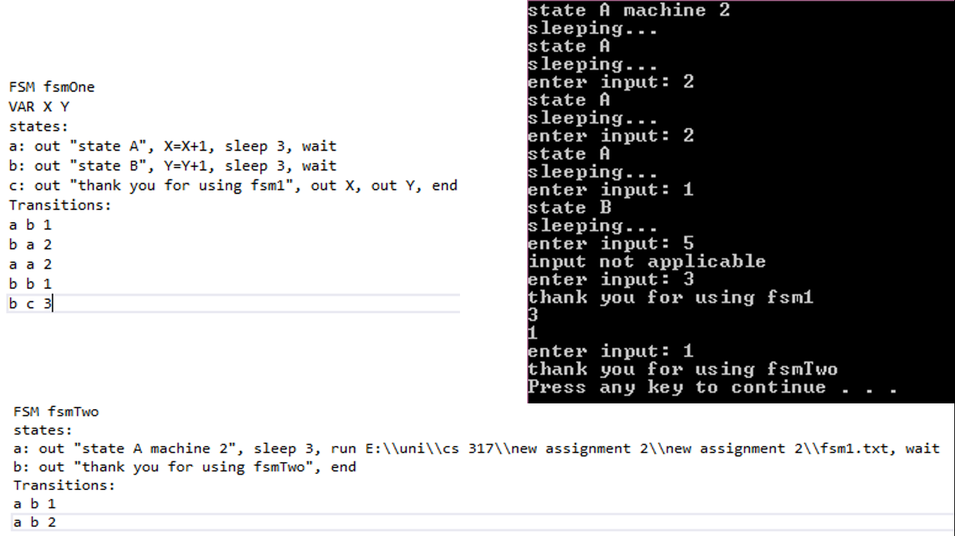**Test FSM**

**Manual to run program**

- Make sure text file looks like the ones above.

- One space between variables

- ", "between actions

- Make sure FSM, VAR, states and Transition are written as they're in the picture above.

- Make sure variables are 1 letter long

- If invalid input is entered, a message is displayed and user is asked to re-enter.

- If state doesn't contain wait/end, the FSM's execution is stopped and a message is displayed.